PSG COLLEGE OF TECHNOLOGY
DEPARTMENT OF APPLIED MATHEMATICS AND COMPUTATIONAL SCIENCES
M.Sc. Data Science – Computer Networks Lab
Worksheet - CYCLIC REDUNDANCY CHECK (CRC)

The purpose of this lab assignment is to make you familiar with the working of CRC and to gain knowledge on how this method is used as an error detection technique during data transmission.

Your task is to write two Python programs to:
- Read binary data from a file (say 1101011011), compute the CRC checksum using a divisor (say 10011), and store the data along with checksum in another file.
- Read the file which contains data along with CRC checksum and detect errors if any (Manually insert error in the file by modifying bit(s)).

Cyclic Redundancy Check

The cyclic redundancy check, or CRC, is a technique for detecting errors in digital data, but not for making corrections when errors are detected. It is used primarily in data transmission.

In the CRC method, a certain number of check bits, often called a checksum, are appended to the message being transmitted. The receiver can determine whether or not the check bits agree with the data, to ascertain with a certain degree of probability whether or not an error occurred in transmission. If an error occurred, the receiver sends a “negative acknowledgement” (NAK) back to the sender, requesting that the message be retransmitted.

Following Diagram shows the working of CRC.
This image shows division at sender side.
Division at Receiver side.

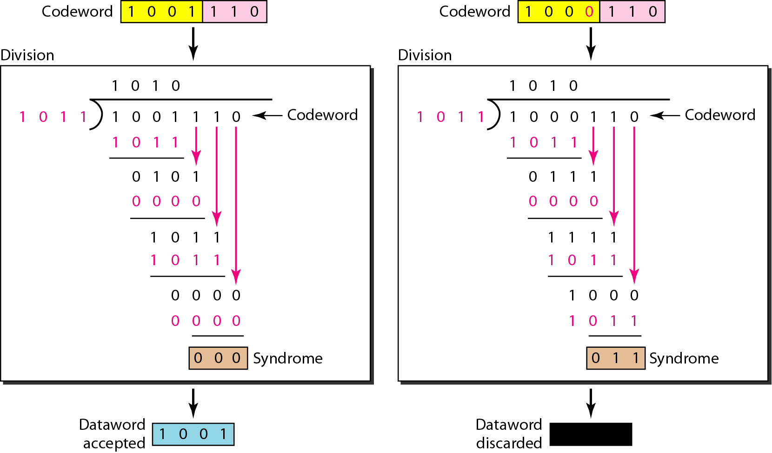
- Bits not corrupted b) Bit marked in red corrupted
during transmission during transmission

